**BATHROOM EXHAUST FANS:**

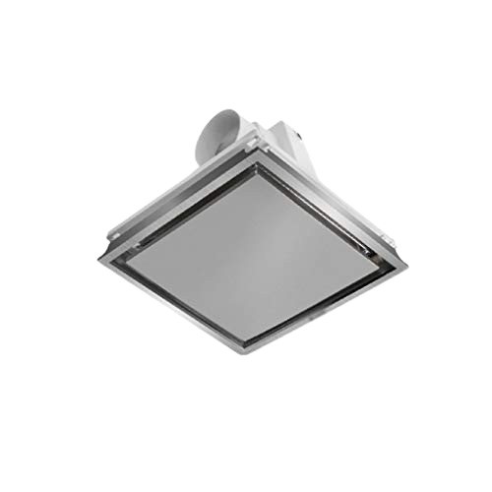

**Price: 3,600.00**

The Bathroom Exhaust Fan is a compact and efficient ventilation solution, specifically designed to remove moisture, odors, and pollutants from bathrooms and toilets. With its quiet operation and low power consumption, this fan provides effective airflow without disrupting the ambiance. Its corrosion-resistant coating and splash-proof design ensure durability in humid environments, while its easy installation and maintenance-free operation make it a practical choice for ensuring a healthy and comfortable bathroom environment.

**Key features of bathroom exhaust fans include:**

* **Moisture Removal:** Efficiently removes excess humidity and moisture to prevent mold and mildew.
* **Quiet Operation:** Designed for minimal noise while in use.
* **Energy Efficient:** Low power consumption for cost-effective operation.
* **Compact Design:** Ideal for small spaces with easy installation.
* **Durable Build:** Built with corrosion-resistant materials for long-lasting use.
* **Improved Air Quality:** Helps maintain fresh air circulation in bathrooms.
* **Effective Ventilation:** Quickly clears odors and steam from the bathroom.